**Exercise 1: Setting Up Junit**

**Xml.java**

<?xml version="1.0" encoding="UTF-8"?>

<project xmlns="http://maven.apache.org/POM/4.0.0"

xmlns:xsi="http://www.w3.org/2001/XMLSchema-instance"

xsi:schemaLocation="http://maven.apache.org/POM/4.0.0

http://maven.apache.org/xsd/maven-4.0.0.xsd">

<modelVersion>4.0.0</modelVersion>

<groupId>org.example</groupId>

<artifactId>Settingupjunit</artifactId>

<version>1.0-SNAPSHOT</version>

<properties>

<maven.compiler.source>21</maven.compiler.source>

<maven.compiler.target>21</maven.compiler.target>

<project.build.sourceEncoding>UTF-8</project.build.sourceEncoding>

</properties>

<dependencies>

<!-- Add JUnit 4.13.2 dependency -->

<dependency>

<groupId>junit</groupId>

<artifactId>junit</artifactId>

<version>4.13.2</version>

<scope>test</scope>

</dependency>

</dependencies>

</project>

**Example java**

public class Calculator {

public int add(int a, int b) {

return a + b;

}

}

**ExampleTest.java**

import org.junit.Test;

import static org.junit.Assert.assertEquals;

public class CalculatorTest {

@Test

public void testAdd() {

Calculator calc = new Calculator();

int result = calc.add(2, 3);

assertEquals(5, result);

}

}

**Output :**

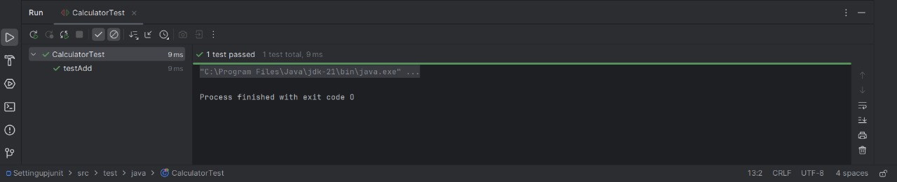

**Exercise 3: Assertions in JUnit Scenario:**

**Xlm java:**

<?xml version="1.0" encoding="UTF-8"?>

<project xmlns="http://maven.apache.org/POM/4.0.0"

xmlns:xsi="http://www.w3.org/2001/XMLSchema-instance"

xsi:schemaLocation="http://maven.apache.org/POM/4.0.0 http://maven.apache.org/xsd/maven-4.0.0.xsd">

<modelVersion>4.0.0</modelVersion>

<groupId>org.example</groupId>

<artifactId>AssertionsinJUnit</artifactId>

<version>1.0-SNAPSHOT</version>

<properties>

<maven.compiler.source>21</maven.compiler.source>

<maven.compiler.target>21</maven.compiler.target>

<project.build.sourceEncoding>UTF-8</project.build.sourceEncoding>

</properties>

<dependencies>

<!-- Unit 5 API -->

<dependency>

<groupId>org.junit.jupiter</groupId>

<artifactId>junit-jupiter</artifactId>

<version>5.10.0</version>

<scope>test</scope>

</dependency>

</dependencies>

<build>

<plugins>

<!-- Maven Surefire Plugin to run tests -->

<plugin>

<groupId>org.apache.maven.plugins</groupId>

<artifactId>maven-surefire-plugin</artifactId>

<version>3.1.2</version>

</plugin>

</plugins>

</build>

</project>

**Example java:**

package org.example;

import org.junit.jupiter.api.Test;

import static org.junit.jupiter.api.Assertions.*;

public class AssertionsTest {

@Test

public void testAssertions() {

assertEquals(5, 2 + 3);

assertTrue(5 > 3);

assertFalse(5 < 3);

assertNull(null);

assertNotNull(new Object());

}

}

**OUTPUT:**

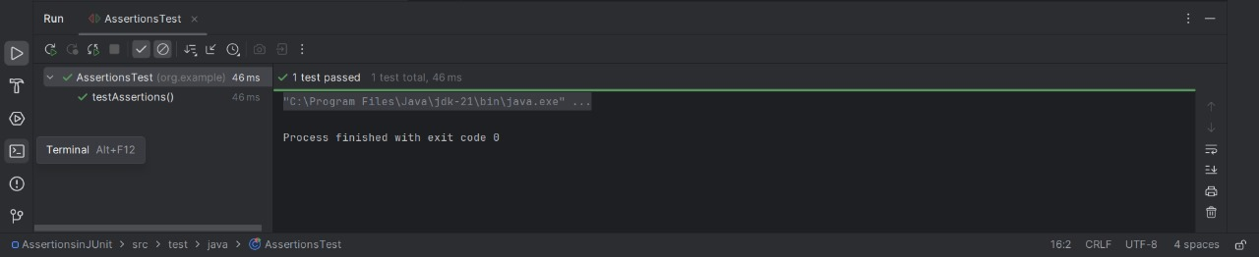

**Exersise 4:Arrange-Act-Assert (AAA) Pattern, Test Fixtures, Setup and**

**Teardown Methods in JUni:**

**Xml java:**

<?xml version="1.0" encoding="UTF-8"?>

<project xmlns="http://maven.apache.org/POM/4.0.0"

xmlns:xsi="http://www.w3.org/2001/XMLSchema-instance"

xsi:schemaLocation="http://maven.apache.org/POM/4.0.0 http://maven.apache.org/xsd/maven-4.0.0.xsd">

<modelVersion>4.0.0</modelVersion>

<groupId>org.example</groupId>

<artifactId>assertionjunit</artifactId>

<version>1.0-SNAPSHOT</version>

<properties>

<maven.compiler.source>21</maven.compiler.source>

<maven.compiler.target>21</maven.compiler.target>

<project.build.sourceEncoding>UTF-8</project.build.sourceEncoding>

</properties>

<dependencies>

<dependency>

<groupId>junit</groupId>

<artifactId>junit</artifactId>

<version>4.13.2</version>

<scope>test</scope>

</dependency>

</dependencies>

</project>

**Exampple java:**

// File: src/Calculator.java

public class Calculator {

public int add(int a, int b) {

return a + b;

}

}

**Java:**

// File: src/CalculatorTest.java

import org.junit.After;

import org.junit.Before;

import org.junit.Test;

import static org.junit.Assert.assertEquals;

public class CalculatorTest {

private Calculator calculator;

@Before

public void setUp() {

System.out.println("Setting up...");

calculator = new Calculator();

}

@After

public void tearDown() {

System.out.println("Cleaning up...");

calculator = null;

}

@Test

public void testAdditionOfTwoPositiveNumbers() {

int result = calculator.add(5, 3);

assertEquals(8, result);

}

@Test

public void testAdditionOfNegativeAndPositiveNumber() {

int result = calculator.add(-2, 4);

assertEquals(2, result);

}

}

**Output:**

